SN Studio Report no. 1 by Zuzanna Szozda

Date of the Report: 15.03.2021

**Hysteresis loops, magnetisation curves and relative magnetic permeabilities**

**of selected pigments used in work of art**

1. **The scope of the research**

The research covers basic magnetic properties (mass magnetisation M, flux density B and relative magnetic permeability µr) of randomly selected pigments used in work of art.

Table 1. Basic information about pigments under consideration



Measurements (in the magnetic field up to H = 100 kA/m at room temperature 300 K) were performed on the Physical Property Measurement System (Quantum Design) equipped with a Vibrating Sample Magnetometer (VSM), option located at the Institute of Molecular Physics, Polish Academy of Science in Poznań, Poland. Two samples of a given pigment were tested each time and the differences in the examined properties do not exceed the accuracy of the measurement method.

1. **Basic terms formulas and units**

**Internal magnetic feature**

**Mass magnetization M**: M = χ · H in emu/g or A/m (1)

where: χ - magnetic relative susceptibility (dimensionless)

χ = µr – 1 and µr - magnetic relative permeability (dimensionless)

H - magnetic field strength A/m

emu/g - electromagnetic unit per gram and $1\frac{emu}{g}$ = $\frac{1}{γ} ·\frac{emu}{{cm}^{3}}$

where: γ – specific density in g/cm3 (always 1 emu/cm3 = 1000 A/m)

**Magnetic polarisation J**: J = B - µ0 · H or J = µ0 (µr - 1) · H T (tesla or $\frac{Vs}{m^{2}}$) (2)

where: B – magnetic induction (flux density), T

µ0 = 1.26 x 10-6 H/m magnetic permeability in vacuum (H – henry or $\frac{Vs}{A}$)

**External magnetic feature**

**Magnetic induction (flux density) B**: B = J + µ0 · H = µ0 · µr · H in T (3)

or B = µ0 (M + H) (4)

**Conclusion**: if mass magnetisation M is measured in emu/g to express M (e.g. (4)) in A/m, the substance specific density γ is needed $(1\frac{emu}{g}$ = $\frac{1000}{γ} A/m)$

1. **Hysteresis loops**

Mass magnetisation M=f(H) and magnetic induction B=f(H) hysteresis loops and corresponding relative magnetic permeabilities µr=f(H) based on primary curves (inside hysteresis) measured for pigments as in Table 1 up to 100 kA/m.

1. **Comparison between mass magnetisation M = f(H) and magnetic induction B = f(H) hysteresis loops.**

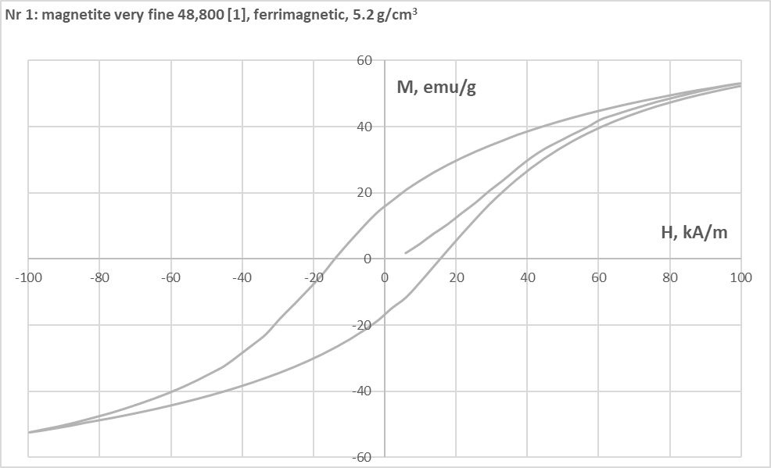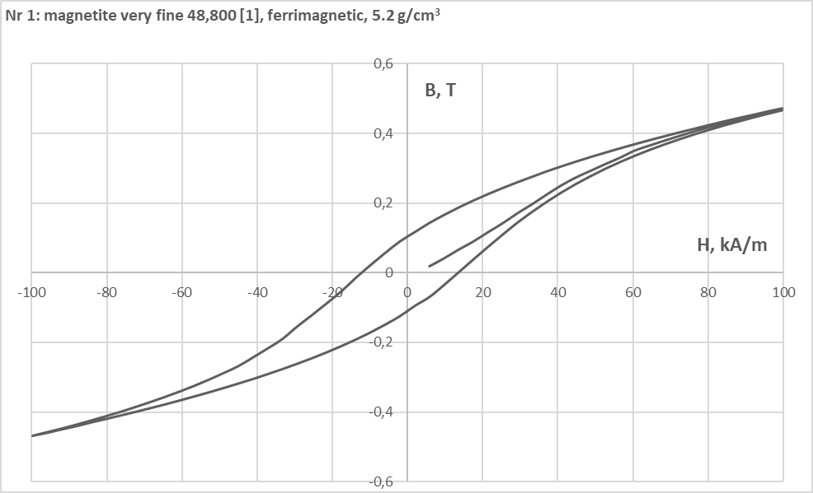

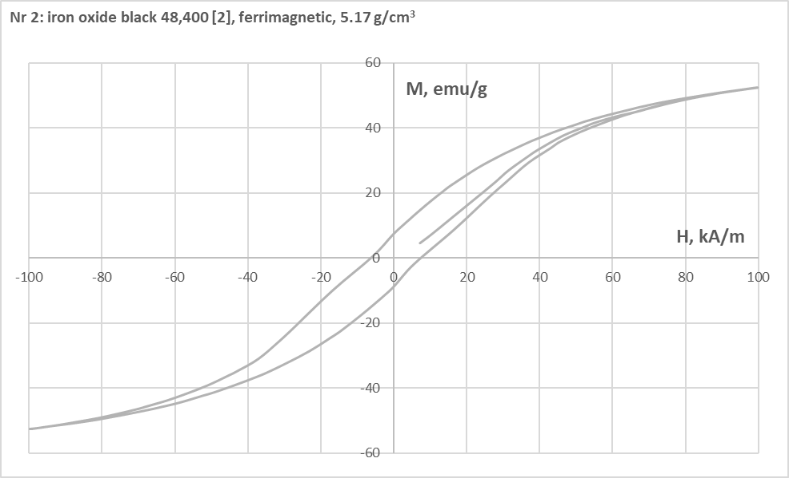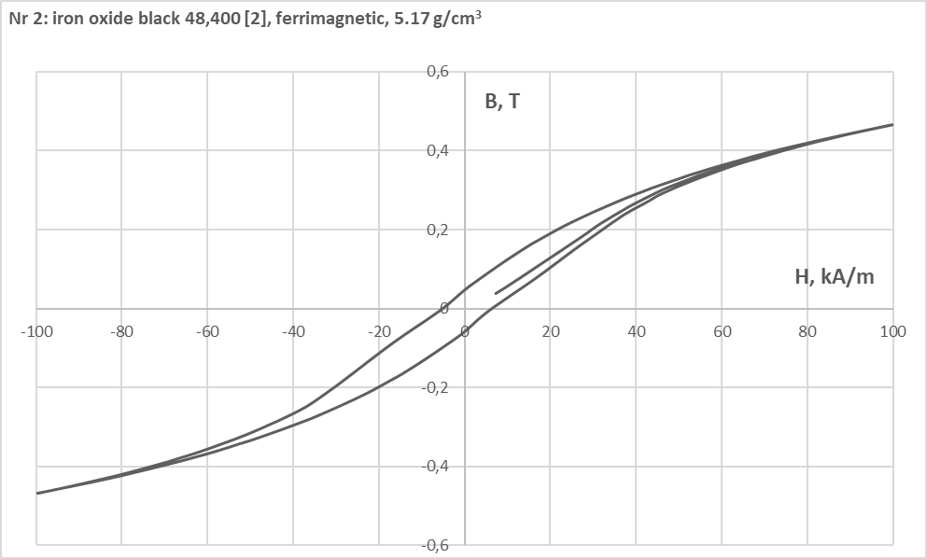

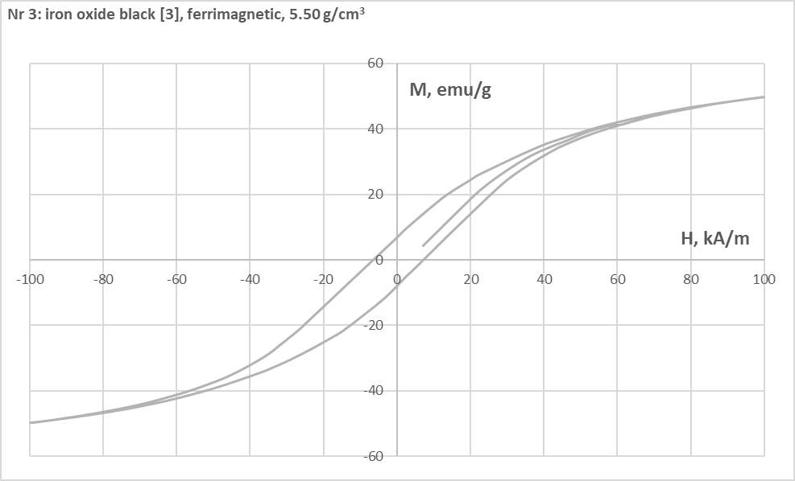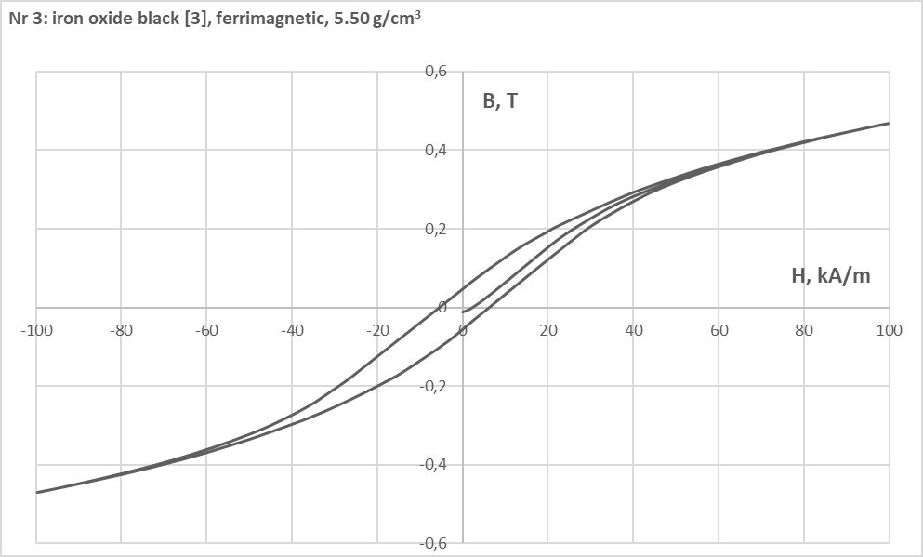

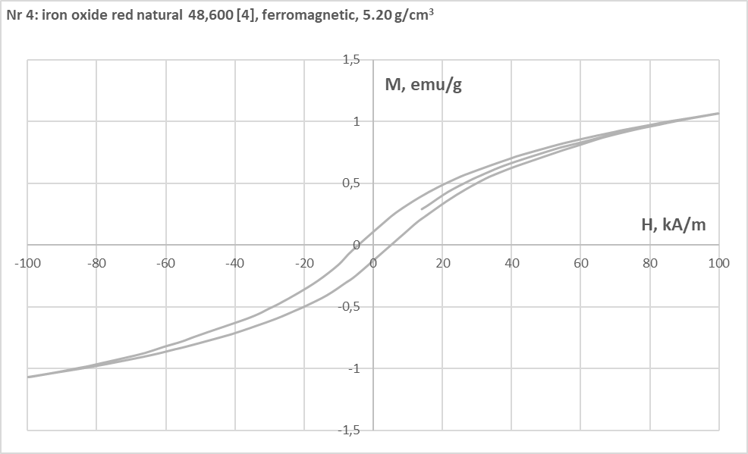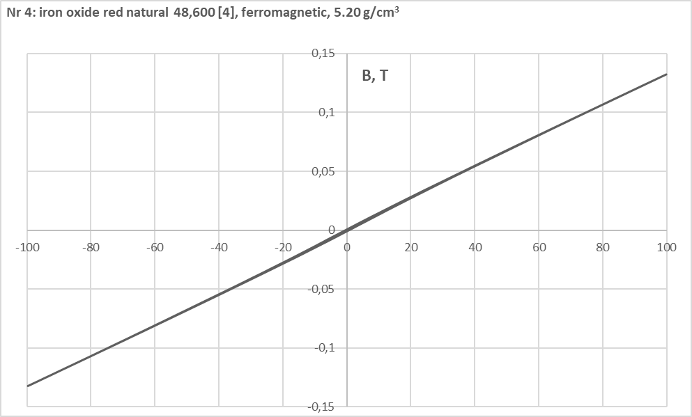

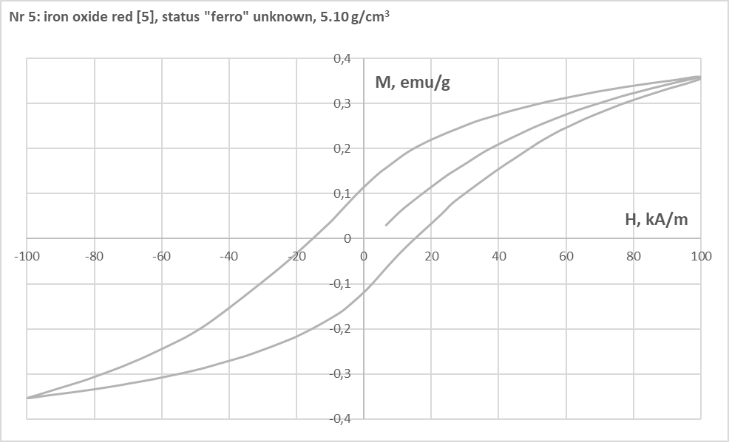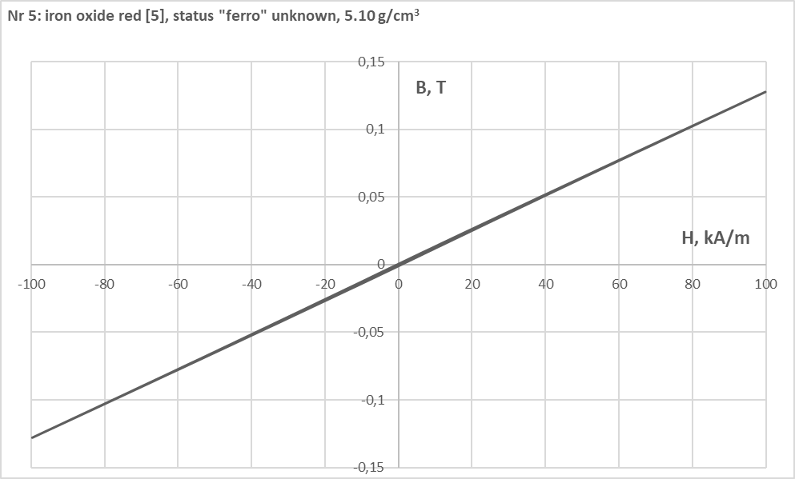

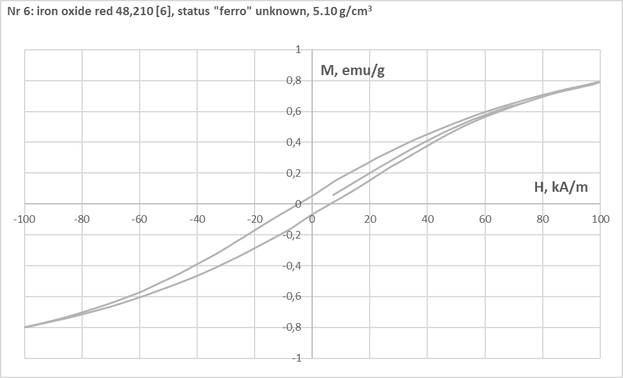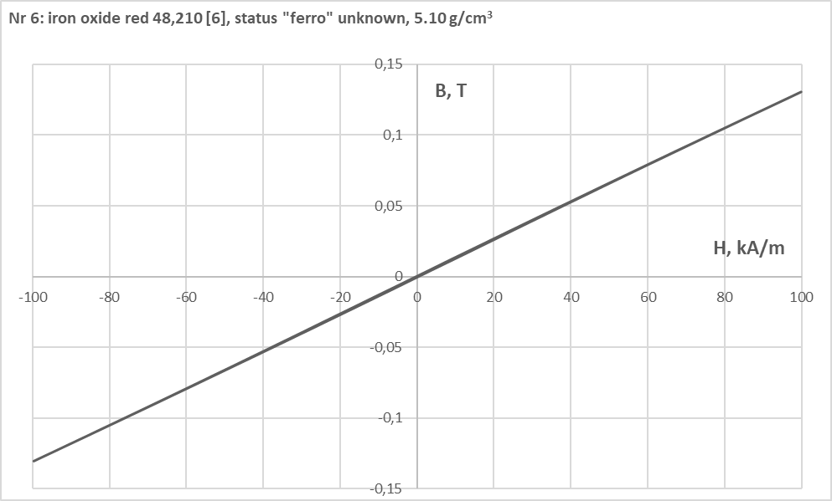

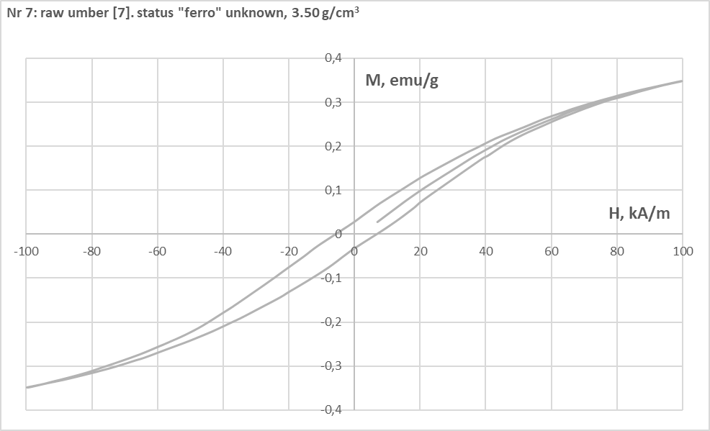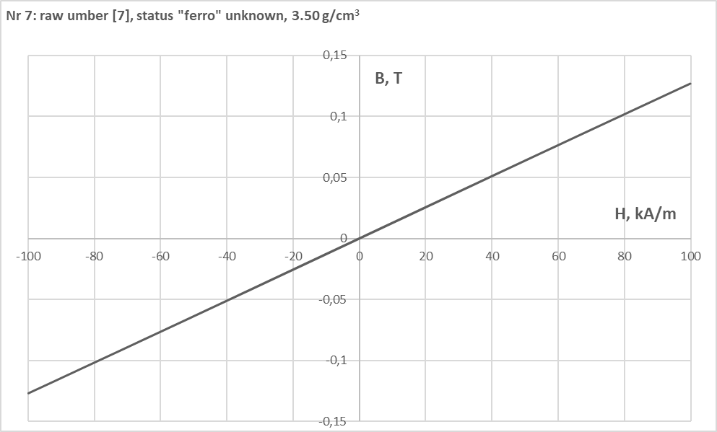

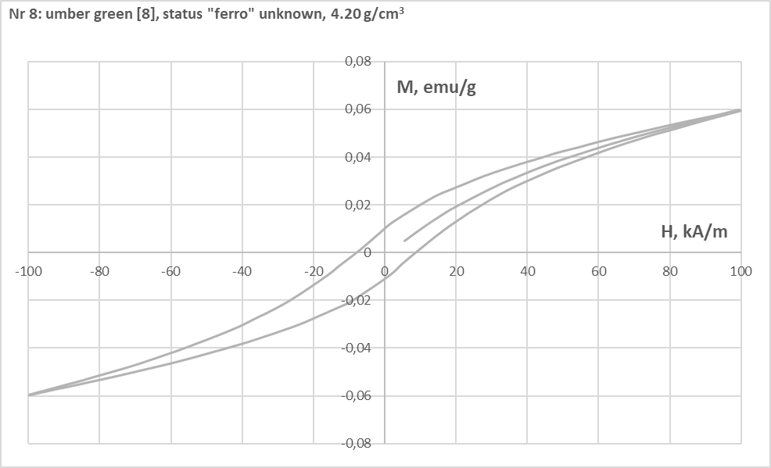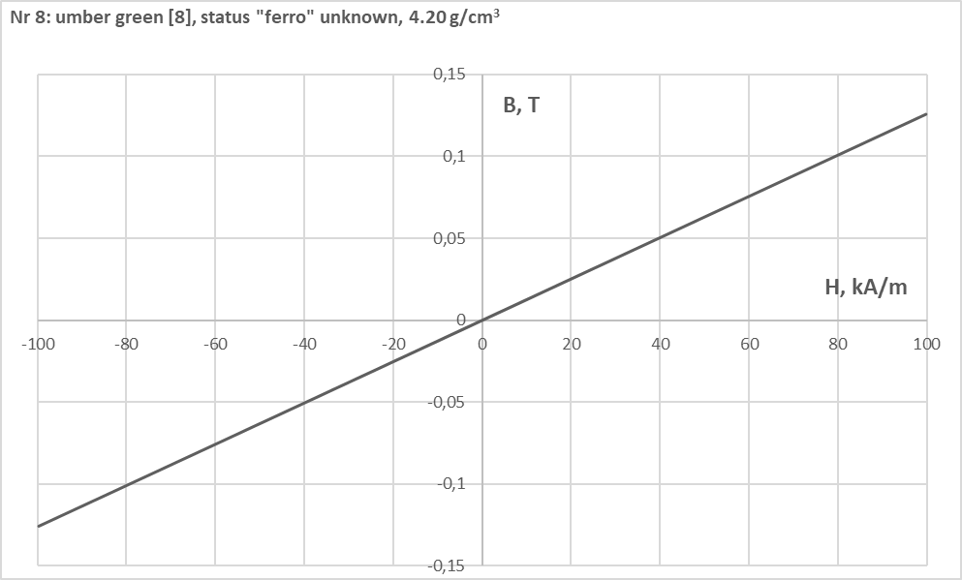

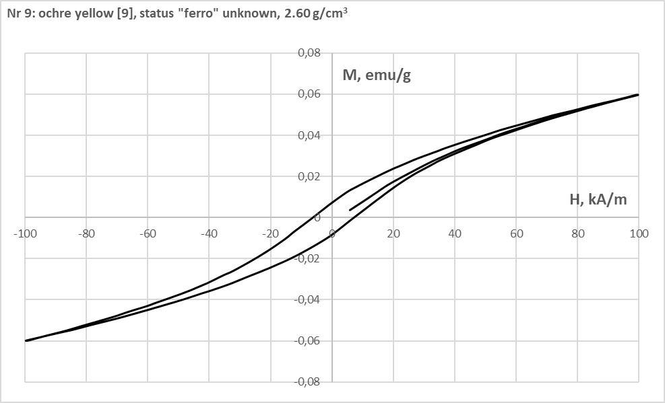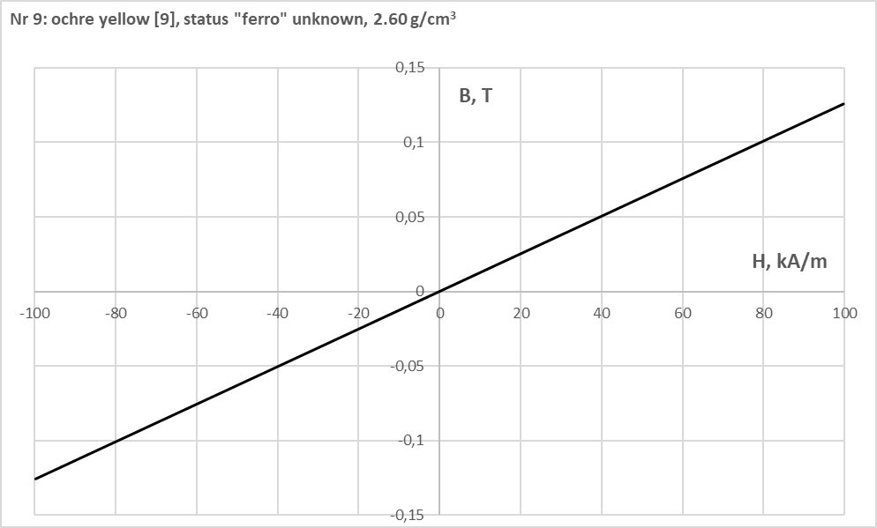

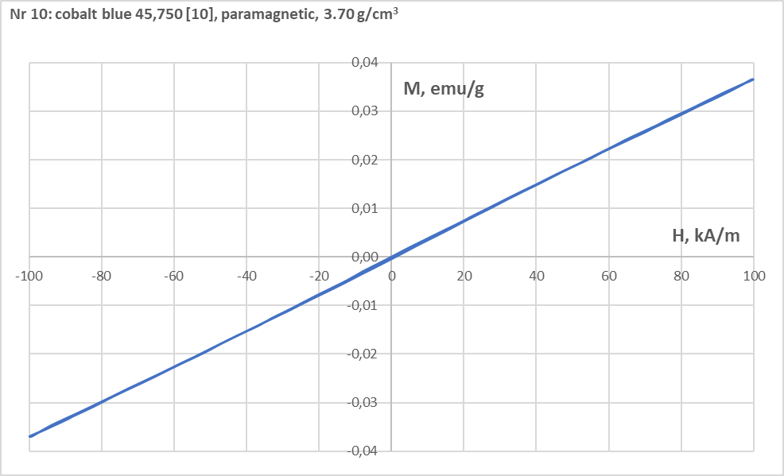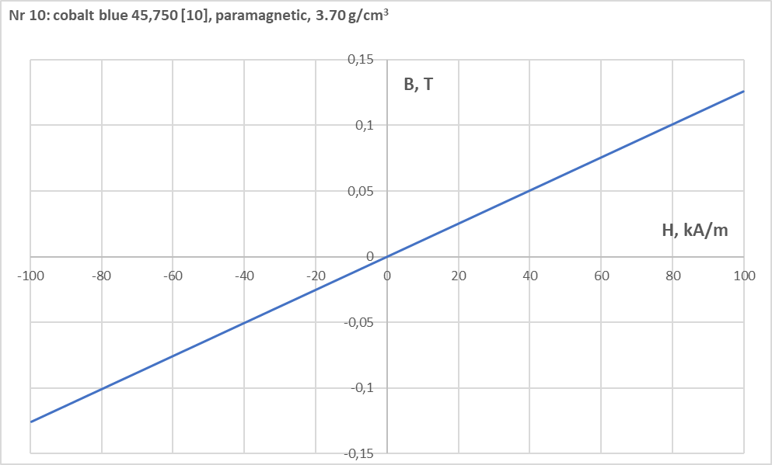

Only mass magnetization M = f(H) hysteresis loops allow proper classification which pigments are magnetic (ferromagnetic – samples 4, 5, 6 or ferrimagnetic – samples 1, 2, 3) or non-magnetic (paramagnetic – sample 10). This is due to the fact that magnetic induction B = f(H) is linearized by adding induction in air to M: (B = µ0 (M + H)). In particular raw umber, umber green and ochre yellow (samples 7, 8, 9) are undouble magnetic because of non-linear hysteresis loops of M = f(H) but with unknown status of ferro- or ferrimagnetic properties. From all pigments under consideration only cobalt blue 45,750 (sample 10) possesses linear hysteresis loop M = f(H). This is the consequence that relative magnetic susceptibility χ = constant at any H > 0 (eq.(1)).

1. **Relative magnetic permeability µr = f(H) based on primary magnetisation measured up to 100 kA/m (solid line) and linearly extrapolated (dashed line) to 500 kA/m initial value and values at 30, 100, 200 and 500 kA/m.**

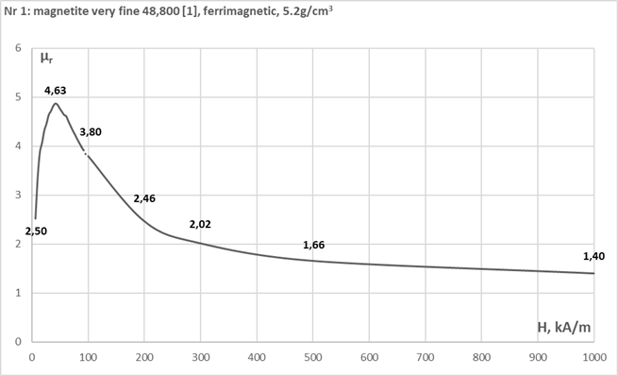

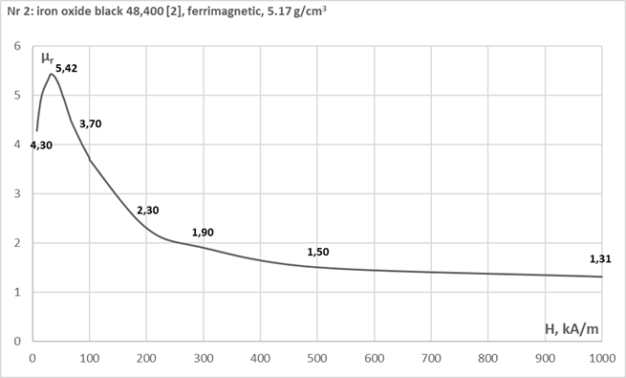

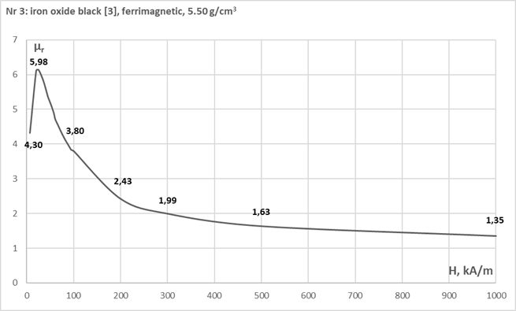

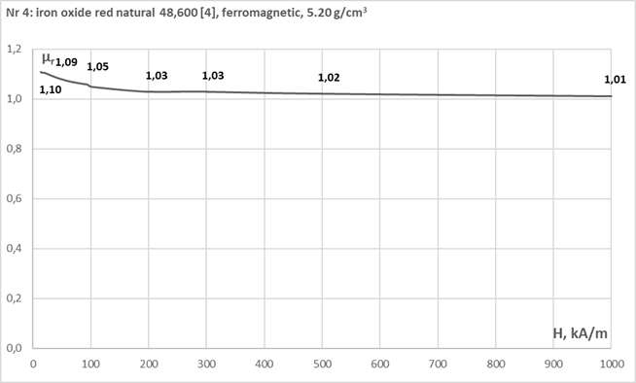

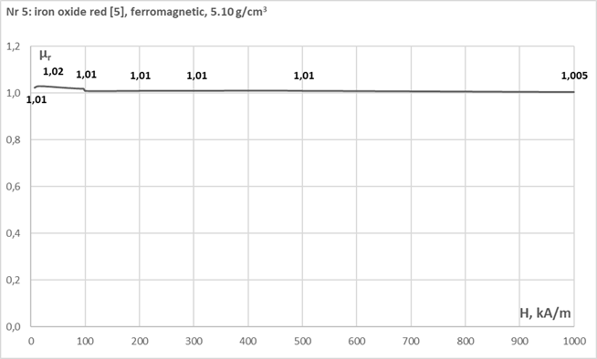

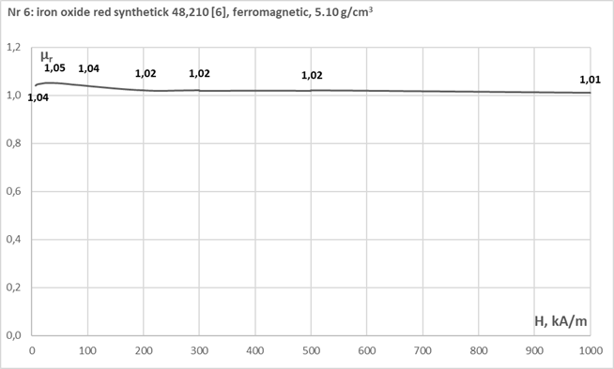

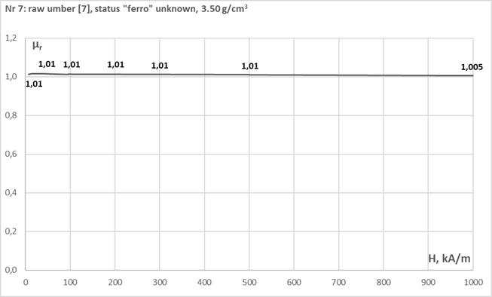

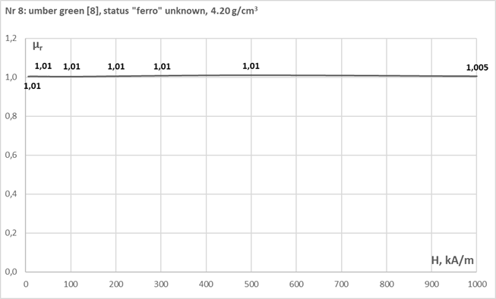

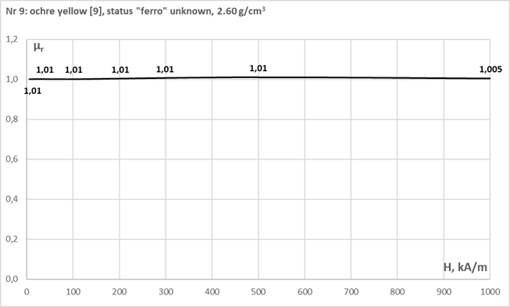

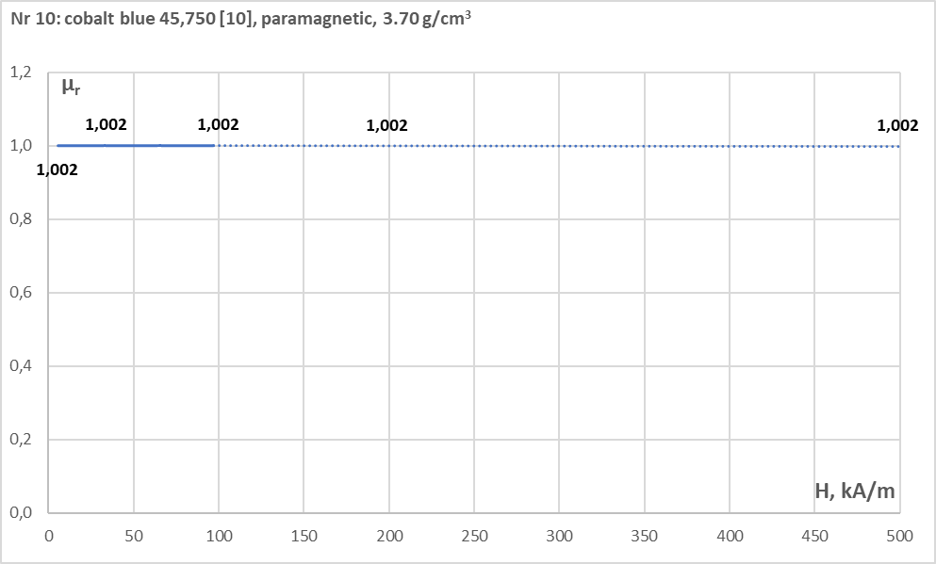

**6. Related publications by the Author**

- The Impact of Magnet on Certain Pigments and Paints Used in the Conservation of paintings and Work of Art, Studies in Conservation, Vol. 66, Issue 1 (2021), pp. 1 -6

- The Magic of Magnetism. The Real Impact of using Magnet in Conservation: Ensuring the Safety of the Art Piece and the Conservator, NKF XXII Congress, Stockholm, 21-22 October 2021 (in print)

- Magnetic Holder with Pressure Adjustment, AIC 49th Annual Conference, Jacksonville 2021 (under review)

- using Magnets with Calculated Pressure on Canvas Support (included in the research plan)

- Acting on Behalf of Canvas Conservators’ and Paintings’ Safety. A Study of Pigments Validation by Magnet Test (manuscript under preparation)

**Acknowledgement**

I would like to thank Dr Roman Rygał of R&D Magneto and Dr Stanisław Żurek of Encyclopedia Magnetica for scientific advice on the interpretation of concepts and systems (Gaussian & cgs emu and SI) of magnetic units and assistance in organization of experimental data.

References

[1] Kremer-Pigmente, Safety Data Sheet No . 48 800 Pigment Magnetite Very Fine. https://www.kremer-pigmente.com/en/pigments-oxide-pigments/1629/magnetite-very fine?number=48800. Online, accessed 7.01.19

[2] Kremer-Pigmente, Safety Data Sheet No . 48 400 Pigment Iron Oxide Black. https://www.kremer-pigmente. com/en/pigments/iron-oxide-pigments/1613/iron-oxide-black-318-high-tinnting. Online, accessed 7.01.19

[3] Iron Oxide Black/Mars Black (Anonymous, IKONA+ART)

[4] Kremer-Pigmente, Safety Data Sheet No . 48 600 Pigment Iron Oxide Red Natural. https://www.kremer-pigmente.com/en/pigments/iron-oxide-pigments/1621/iron-oxide-red-natural?number=48600. http://www.kremerpolska.com/katalog/pigmenty_zelazowe.htm. Online, accessed 7.01.19

[5] Iron Oxide Red/Mars Red (Anonymous, IKONA+ART)

[6] Kremer-Pigmente, Safety Data Sheet No . 48 210 Pigment Iron Oxide Red Synthetic. https://www.kremerpolska.com/katalog/pigmenty_zelazowe_synt.htm. Online, accessed 7.01.19

[7] Raw Umber (Anonymous, IKONA+ART)

[8] Umber Green (Anonymous, IKONA+ART)

[9] Ochre Yellow (Anonymous, IKONA+ART)

[10] Kremer-Pigmente, 45 750 Pigment Cobalt Blue. http://www.kremerpolska.com/katalog/pigmenty_blekitne.htm. Online, accessed 7.01.19